

# 

### Semester Two Examination, 2016

### Question/Answer Booklet

# MATHEMATICS

**SOLUTIONS**

**METHODS**

**UNITS 3 AND 4**

## Section Two:

## Calculator-assumed

|  |  |  |  |  |  |  |  |  |
| --- | --- | --- | --- | --- | --- | --- | --- | --- |
| Student Number: In figures |  |  |  |  |  |  |  |  |

In words

Your name

## Time allowed for this section

Reading time before commencing work: ten minutes

Working time for section: one hundred minutes

## Materials required/recommended for this section

***To be provided by the supervisor***

This Question/Answer Booklet

Formula Sheet (retained from Section One)

***To be provided by the candidate***

Standard items: pens (blue/black preferred), pencils (including coloured), sharpener, correction fluid/tape, eraser, ruler, highlighters

Special items: drawing instruments, templates, notes on two unfolded sheets of A4 paper, and up to three calculators approved for use in the WACE examinations

## Important note to candidates

No other items may be taken into the examination room. It is **your** responsibility to ensure that you do not have any unauthorised notes or other items of a non-personal nature in the examination room. If you have any unauthorised material with you, hand it to the supervisor **before** reading any further.

## Structure of this paper

|  |  |  |  |  |  |
| --- | --- | --- | --- | --- | --- |
| Section | Number of questions available | Number of questions to be answered | Working  time (minutes) | Marks available | Percentage of exam |
| Section One:  Calculator-free | 7 | 7 | 50 | 52 | 35 |
| Section Two:  Calculator-assumed | 13 | 13 | 100 | 98 | 65 |
|  | | | **Total** | 150 | 100 |

## Instructions to candidates

1. The rules for the conduct of examinations are detailed in the school handbook. Sitting this examination implies that you agree to abide by these rules.

2. Write your answers in this Question/Answer Booklet.

3. You must be careful to confine your response to the specific question asked and to follow any instructions that are specified to a particular question.

4. Spare pages are included at the end of this booklet. They can be used for planning your responses and/or as additional space if required to continue an answer.

* Planning: If you use the spare pages for planning, indicate this clearly at the top of the page.
* Continuing an answer: If you need to use the space to continue an answer, indicate in the original answer space where the answer is continued, i.e. give the page number. Fill in the number of the question that you are continuing to answer at the top of the page.

5. **Show** **all your working clearly**. Your working should be in sufficient detail to allow your answers to be checked readily and for marks to be awarded for reasoning. Incorrect answers given without supporting reasoning cannot be allocated any marks. For any question or part question worth more than two marks, valid working or justification is required to receive full marks. If you repeat any question, ensure that you cancel the answer you do not wish to have marked.

6. It is recommended that you **do not use pencil**, except in diagrams.

7. The Formula Sheet is **not** to be handed in with your Question/Booklet.

Section Two: Calculator-assumed 65% (98 Marks)

This section has**thirteen (****13)** questions. Answer **all** questions. Write your answers in the spaces provided.

Working time for this section is 100 minutes.

Question 8 (5 marks)

Zebra mussels are an invasive species of shellfish recently discovered in some North American waterways. The mussel density, $D$, in shellfish per square metre, observed in a power station water supply pipe $t$ days after a colony began, was modelled by the following equation, where $k$ is a positive constant:

$$D=200e^{kt}$$

(a) What was the mussel density in the colony when observations began? (1 mark)

|  |
| --- |
| **Solution** |
| $$t=0⇒D=200$$ |
| **Specific behaviours** |
| ✓ states initial value |

The mussel density was observed to double every eight days.

(b) Determine the value of $k$, rounded to four decimal places. (2 marks)

|  |
| --- |
| **Solution** |
| $$e^{8k}=2 \\ k=0.0866$$ |
| **Specific behaviours** |
| ✓ substitutes values into equation  ✓ solves to required degree of accuracy |

(c) The water supply pipe was seriously compromised when the mussel density reached 85 thousand shellfish per square metre. After how many days from the commencement of observations did this happen? (2 marks)

|  |
| --- |
| **Solution** |
| $$85000=200e^{0.0866t}$$ $$t=69.9≈70 \text{days}$$ |
| **Specific behaviours** |
| ✓ substitutes values into equation  ✓ solves for number of days |

Question 9 (6 marks)

The speeds of 250 vehicles, on a section of freeway undergoing roadworks with a speed limit of 60 kmh-1, had a mean and standard deviation of 56.9 kmh-1 and 3.6 kmh-1 respectively. A summary of the data is shown in the table below.

|  |  |  |  |  |  |
| --- | --- | --- | --- | --- | --- |
| Speed ( kmh-1) |  |  |  |  |  |
| Relative frequency | 0.024 | 0.272 | 0.504 | 0.188 | 0.012 |

(a) Use the table of relative frequencies to estimate the probability that the next vehicle to pass the roadworks

(i) was not exceeding the speed limit. (1 mark)

|  |
| --- |
| **Solution** |
| $$0.024+0.272+0.504=0.8$$ |
| **Specific behaviours** |
| ✓ states probability |

(ii) had a speed of less than 65 kmh-1, given they were exceeding the speed limit.

(1 mark)

|  |
| --- |
| **Solution** |
| $$\frac{0.188}{1-0.8}=0.94$$ |
| **Specific behaviours** |
| ✓ calculates probability |

(b) Subsequent tests on the measuring equipment discovered that it had been wrongly calibrated. The correct speed of each vehicle, $v$, could be calculated from the measured speed, $x$, by increasing $x$ by 6% and then adding 1.7.

(i) Calculate the adjusted mean and standard deviation of the vehicle speeds.

(2 marks)

|  |
| --- |
| **Solution** |
| $$\overline{v}=56.9×1.06+1.7≈62.0 {\text{kmh}}^{-1} \\ sd_{v}=3.6×1.06≈3.82 {\text{kmh}}^{-1}$$ |
| **Specific behaviours** |
| ✓ calculates new mean  ✓ calculates new sd |

(ii) Determine the correct proportion of vehicles that were speeding. (2 marks)

|  |
| --- |
| **Solution** |
| $60=x×1.06+1.7⇒x=55$ Hence $0.504+0.188+0.012=0.704$ is correct proportion. |
| **Specific behaviours** |
| ✓ determines  ✓ states proportion |

Question 10 (8 marks)

A student planned to investigate what proportion of the 1260 students at their school had access to more than one computer at home.

(a) The student thought of the following three ways to select a sample from the population. Briefly discuss the main source of bias in each method.

(i) Wait at the bus-bay after school and ask the first 50 students who show up.

(1 mark)

|  |
| --- |
| **Solution** |
| Biased towards students who catch bus. |
| **Specific behaviours** |
| ✓ identifies group bias |

(ii) Advertise the survey in a whole school assembly and ask the first 50 students who volunteer to stay behind. (1 mark)

|  |
| --- |
| **Solution** |
| Self-selected samples are likely to suffer from non-response bias. |
| **Specific behaviours** |
| ✓ identifies self-selection bias |

(iii) Select and ask every 100th student from the school roll. (1 mark)

|  |
| --- |
| **Solution** |
| Small samples likely to be biased - in this case sample of only 13. |
| **Specific behaviours** |
| ✓ identifies small sample bias |

(b) Assuming that 80% of students had access to more than one computer at home, the student carried out 100 simulations in which a sample proportion was calculated from a random sample of 64 students.

(i) Explain why it is reasonable to expect that the distribution of the sample proportions would approximate normality. (2 marks)

|  |
| --- |
| **Solution** |
| The sample size of 64 is reasonably large ($n≥30$).  Also, both $np [=51.2]$ and $n\left(1-p\right) [=12.8]$ exceed the rule-of thumb minimum of 10. |
| **Specific behaviours** |
| ✓ states large sample size  ✓ indicates dependence on both $n$ and $p$ |

(ii) Determine the mean and standard deviation of the normal distribution that the sample proportions would approximate. (2 marks)

|  |
| --- |
| **Solution** |
| Mean of $0.8$ Standard deviation of $\sqrt{\frac{0.8\left(1-0.8\right)}{64}}=0.05$ |
| **Specific behaviours** |
| ✓ states mean  ✓ states standard deviation |

Question 11 (10 marks)

(a) The graph below shows the curve $y=f(x)$, where $f\left(x\right)=\frac{12}{2x-1}$.

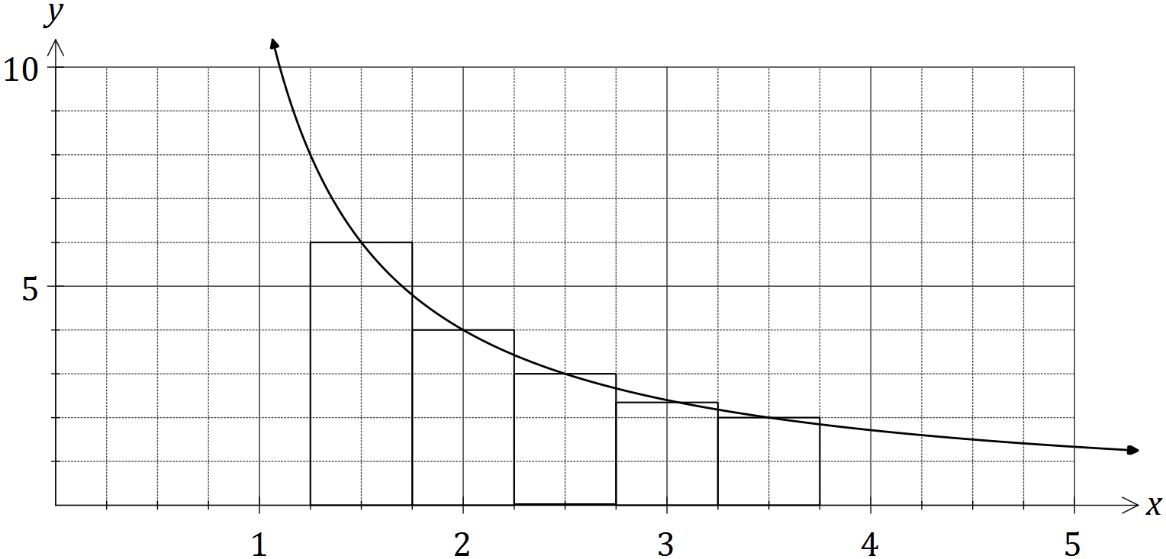

Use the five centred rectangles shown to estimate the shaded area under the curve from $x=1.25$ to $x=3.75$. (3 marks)

|  |
| --- |
| **Solution** |
| $$f\left(1.5\right)=6, f\left(2\right)=4, f\left(2.5\right)=3, f\left(3\right)=2.4, f\left(3.5\right)=2$$ $$A≈\frac{1}{2}×(6+4+3+2.4+2)$$ $$A≈8.7 \text{sq units}$$ |
| **Specific behaviours** |
| ✓ calculates five rectangle heights  ✓ sums rectangles  ✓ states area estimate |

(b) Given $\int_{a}^{b}{h(x)}dx=k$ and $h(x)$ is a polynomial, determine the following in terms of the constants $a, b$ and $k$:

(i) $\int_{a}^{b}{3 h(x)}dx$. (1 mark)

|  |
| --- |
| **Solution** |
| $$3k$$ |
| **Specific behaviours** |
| ✓ states answer |

(ii) $\int_{a}^{b}{2- h(x)}dx$. (2 marks)

|  |
| --- |
| **Solution** |
| $$\int_{a}^{b}{2- h(x)}dx=\int_{a}^{b}{2}dx-\int_{a}^{b}{h(x)}dx \\ =2b-2a-k$$ |
| **Specific behaviours** |
| ✓ splits integral  ✓ simplifies |

(c) The graphs of $y=\cos^{2}\left(x+\frac{π}{6}\right)$ and $y=\frac{3}{4}$ are shown below. Determine the exact area of the shaded region they enclose. (4 marks)

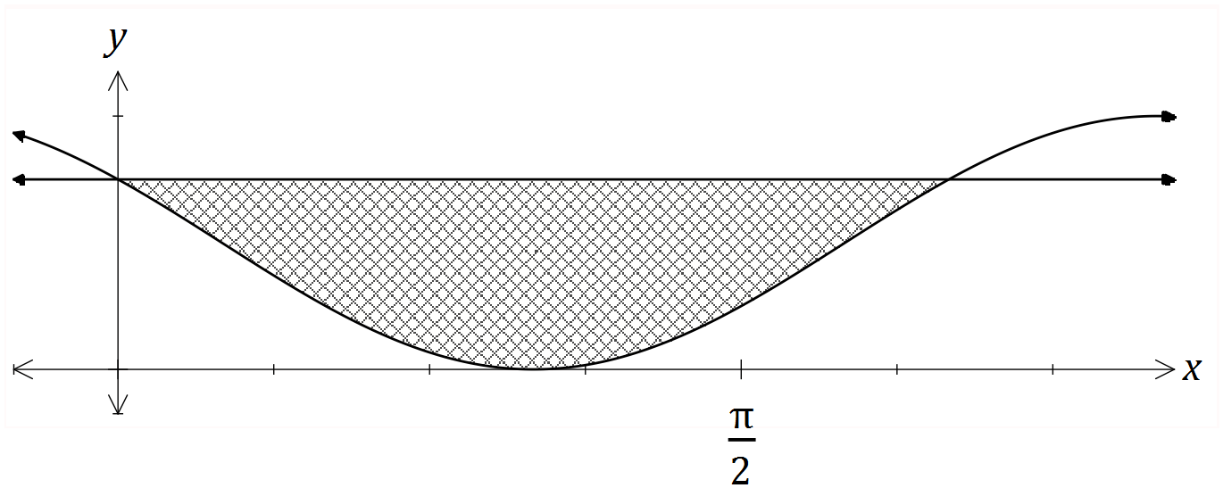

|  |
| --- |
| **Solution** |
| $$\cos^{2}\left(x+\frac{π}{6}\right)=\frac{3}{4}⇒x=0,\frac{2π}{3} \\ A=\int_{0}^{2π/3}{\frac{3}{4}-\cos^{2}\left(x+\frac{π}{6}\right)} dx \\ A=\frac{π}{6}+\frac{\sqrt{3}}{4} \text{sq units}$$ |
| **Specific behaviours** |
| ✓ solves intersection of functions  ✓ writes required integral  ✓ uses exact values throughout  ✓ evaluates integral exactly |

Question 12 (8 marks)

A box contains a large number of packets of buttons. The number of buttons in a packet may be modelled by the random variable $X$, with the probability distribution shown below. It is also known that $E\left(X\right)=6.25$.

|  |  |  |  |  |  |  |  |
| --- | --- | --- | --- | --- | --- | --- | --- |
| $$x$$ | 3 or fewer | 4 | 5 | 6 | 7 | 8 | 9 or more |
| $$P(X=x)$$ | 0 | 0.05 | a | b | 0.25 | 0.15 | 0 |

(a) Two packets are randomly chosen from the box. Determine the probability that there are at least 15 buttons altogether in the two packets. (2 marks)

|  |
| --- |
| **Solution** |
| $P=0.25×0.15+0.15×0.25+0.15×0.15$ $P=0.0975$ |
| **Specific behaviours** |
| ✓ chooses (7,8), (8,7) and (8,8)  ✓ calculates probability |

(b) Determine the values of $a$ and $b$. (3 marks)

|  |
| --- |
| **Solution** |
| From sum of probabilities, $a+b=1-0.45=0.55$ From $E\left(X\right)$, $5a+6b=6.25-3.15=3.1$ Solve simultaneously to get $a=0.2, b=0.35$ |
| **Specific behaviours** |
| ✓ uses sum to 1  ✓ uses  ✓ solves for a and b |

(c) Calculate $\operatorname{Var}{(X)}$. (1 mark)

|  |
| --- |
| **Solution** |
| Using technology, $\operatorname{Var}{(X)}=1.1875$ |
| **Specific behaviours** |
| ✓ calculates variance |

(d) As part of a fundraiser, patrons pay 75 cents to select a packet at random and then win back 10 cents for each button in the packet. If the random variable $W$ represents the net gain per game for a patron in cents, determine the mean and variance of $W$. (2 marks)

|  |
| --- |
| **Solution** |
| $E\left(W\right)=10×E\left(X\right)-75=10×6.25-75=-12.5$ $\operatorname{Var}\left(W\right)={10}^{2}×\operatorname{Var}{(X)}=118.75$ |
| **Specific behaviours** |
| ✓ calculates mean  ✓ calculates variance |

Question 13 (7 marks)

A hardware store sells stakes, of nominal length 1.8 metres, to be used for supporting newly planted trees. The length, $X$ metres, of the stakes can be modelled by a normal distribution with mean 1.85 and standard deviation $σ$.

(a) If $σ=0.035$, determine

(i) the probability that a randomly chosen stake is shorter than 1.8 metres. (1 mark)

|  |
| --- |
| **Solution** |
| $$P\left(X<1.8\right)=0.0766$$ |
| **Specific behaviours** |
| ✓ calculates probability |

(ii) the probability that a randomly chosen stake is longer than 1.79 m given that it is shorter than 1.8 metres. (2 marks)

|  |
| --- |
| **Solution** |
| $$P=\frac{P\left(1.79<X<1.8\right)}{P\left(X<1.8\right)} \\ P=\frac{0.0333}{0.0766}≈0.435$$ |
| **Specific behaviours** |
| ✓ calculates numerator  ✓ calculates probability |

(iii) the value of $k$, if the longest 15% of stakes exceed $k$ metres in length. (1 mark)

|  |
| --- |
| **Solution** |
| $$P\left(X>k\right)=0.15⇒k=1.886$$ |
| **Specific behaviours** |
| ✓ determines $k$ |

(b) A large number of stakes were measured and it was found that 97% of them were longer than their nominal length. Show how to use this information to deduce that the value of $σ$ is 0.027 when rounded to three decimal places. (3 marks)

|  |
| --- |
| **Solution** |
| $$P\left(Z>z\right)=0.97⇒z=-1.881 \\ \frac{1.8-1.85}{σ}=-1.881 \\ σ=\frac{-0.05}{-1.881} \\ =0.02658≈0.027 (\text{3 dp})$$ |
| **Specific behaviours** |
| ✓ shows z-score for 97%  ✓ shows use of standardising formula  ✓ solves equation more than 3 dp |

Question 14 (8 marks)

The random variable $X$ denotes the number of hours that a business telephone line is in use per nine hour working day.

The probability density function of $X$ is given by $f\left(x\right)=\left\{\begin{matrix}\frac{{\left(x-a\right)}^{2}+b}{k} & 0≤x≤9 \\ 0 & \text{otherwise}\end{matrix}\right.$,

where $a$, $b$ and $k$ are constants.

(a) If $a=15$ and $b=3$, determine the value of $k$. (2 marks)

|  |
| --- |
| **Solution** |
| $$\int_{0}^{9}{\frac{{\left(x-15\right)}^{2}+3}{k}}dx=1⇒\frac{1080}{k}=1 \\ \text{Hence }k=1080.$$ |
| **Specific behaviours** |
| ✓ writes correct integral  ✓ evaluates integral and states value of $k$ |

(b) Let $a=16$, $b=1$ and $k=1260$.

(i) The business is open for work for 308 days per year. On how many of these days can the business expect the phone line to be in use for more than eight hours?

(2 marks)

|  |
| --- |
| **Solution** |
| $$\int_{8}^{9}{\frac{{\left(x-16\right)}^{2}+1}{1260}}dx=0.0455$$ $$308×0.0455=14 \text{days}$$ |
| **Specific behaviours** |
| ✓ evaluates integral  ✓ calculates number of days |

(ii) Determine, correct to two decimal places, the mean and variance of $X$. (4 marks)

|  |
| --- |
| **Solution** |
| $$E\left(X\right)=\int_{0}^{9}{x×\frac{{\left(x-16\right)}^{2}+1}{1260}}dx=3.39 \\ \operatorname{Var}{(X)}=\int_{0}^{9}{{\left(x-3.39\right)}^{2}×\frac{{\left(x-16\right)}^{2}+1}{1260}}dx=5.78$$ |
| **Specific behaviours** |
| ✓ writes integral for mean  ✓ determines mean  ✓ writes integral for variance  ✓ determines variance |

Question 15 (8 marks)

An analysis of the number of dogs registered by each household within a suburb resulted in the following information:

|  |  |  |  |  |
| --- | --- | --- | --- | --- |
| Number of dogs registered | 0 | 1 | 2 | 3 or more |
| Percentage of households | 21 | 44 | 27 | 8 |

(a) A council worker selects households at random to visit. What is the probability that the first five households visited all have at least one dog registered? (2 marks)

|  |
| --- |
| **Solution** |
| $$p=1-0.21=0.79 \\ {0.79}^{5}=0.3077$$ |
| **Specific behaviours** |
| ✓ calculates probability one household has at least one dog  ✓ calculates probability |

(b) A random sample of 40 households within the suburb is selected.

Use a binomial distribution with $n=40$, together with relevant information from the table in each case, to determine the probability that the sample contains:

(i) exactly 6 households with no dogs registered. (2 marks)

|  |
| --- |
| **Solution** |
| $$X\sim B\left(40, 0.21\right) \\ P\left(X=6\right)=0.1088$$ |
| **Specific behaviours** |
| ✓ uses correct p  ✓ calculates probability |

(ii) no more than 15 households with at least two dogs registered. (2 marks)

|  |
| --- |
| **Solution** |
| $$0.27+0.08=0.35 \\ X\sim B\left(40, 0.35\right) \\ P\left(X≤15\right)=0.6946$$ |
| **Specific behaviours** |
| ✓ uses correct p  ✓ calculates probability |

(c) A random sample of 25 households within the city is to be selected. If $X$ is the number of households in the sample that have exactly one dog registered, determine the mean and variance of $X$. (2 marks)

|  |
| --- |
| **Solution** |
| $$n=25, p=0.44, \overline{x}=25×0.44=11 \\ σ^{2}=11×\left(1-0.44\right)=6.16$$ |
| **Specific behaviours** |
| ✓ calculates mean  ✓ calculates variance |

Question 16 (9 marks)

The management at a conference centre was concerned about the quality of the free pens that it provided in its meeting rooms. A staff member tested a random sample of 150 pens and found that 18 of them fail to write.

(a) If $p$ is the true proportion of pens that fail to write and $\hat{p}$ is the corresponding sample proportion, use the above sample to determine

(i) $\hat{p}$. (1 mark)

|  |
| --- |
| **Solution** |
| $$18÷150=\frac{3}{25}=0.12$$ |
| **Specific behaviours** |
| ✓ calculates $\hat{p}$ |

(ii) the approximate margin of error for a 98% confidence interval for $p$. (3 marks)

|  |
| --- |
| **Solution** |
| $$98\%⇒z=2.326 \\ se=\sqrt{\frac{0.12(1-0.12)}{150}}≈0.02653 \\ E=2.2326×0.02653≈0.0617$$ |
| **Specific behaviours** |
| ✓ calculates z-score  ✓ calculates standard error  ✓ calculates margin of error |

(iii) an approximate 98% confidence interval for $p$. (1 mark)

|  |
| --- |
| **Solution** |
| $$0.12±0.0617≈0.0583<p<0.1817$$ |
| **Specific behaviours** |
| ✓ evaluates interval |

(b) The stationery company that supplies pens to the conference centre claim that no more than 3 in 50 pens fail to write. Use your previous working to comment on the validity of this claim. (2 marks)

|  |
| --- |
| **Solution** |
| $3÷50=0.06$.  The interval calculated in (a) contains 0.06 and so the claim is valid. |
| **Specific behaviours** |
| ✓ compares proportion to confidence interval.  ✓ states claim is valid |

(c) Comment on how the margin of error would change in (a) (ii) if

(i) the quality of the pens had been better. (1 mark)

|  |
| --- |
| **Solution** |
| Decrease, as $p$ is further from 0.5. |
| **Specific behaviours** |
| ✓ states change |

(ii) the required level of confidence decreased. (1 mark)

|  |
| --- |
| **Solution** |
| Decrease, as z-score lower. |
| **Specific behaviours** |
| ✓ states change |

Question 17 (7 marks)

A trough for holding water is to be formed by taking a length of metal sheet 70 cm wide and folding 15 cm on either end, up through an angle of $θ$. The following diagram shows the cross-section of the trough with the cross-sectional area, $A$, shaded.

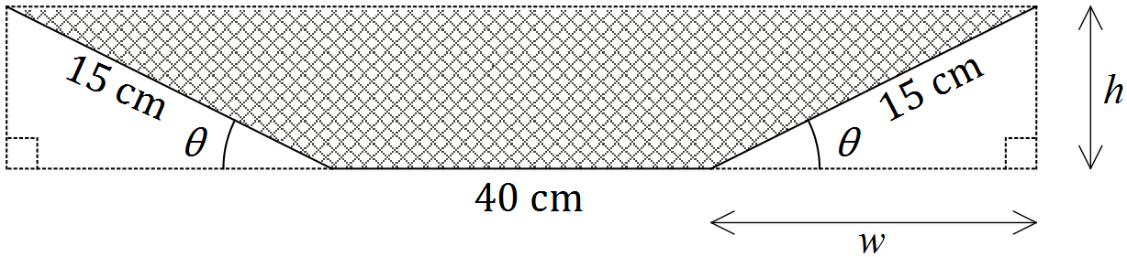

(a) Determine $A$ in terms of $w$ and $h$. (1 mark)

|  |
| --- |
| **Solution** |
| $$A=40h+wh$$ |
| **Specific behaviours** |
| ✓ writes area as required |

(b) Show that $A=600\sin{θ}+225\sin{θ}\cos{θ}$. (2 marks)

|  |
| --- |
| **Solution** |
| $$w=15\cos{θ} \text{and} h=15\sin{θ} \\ A=40×15\sin{θ}+15\cos{θ}×15\sin{θ} \\ A=600\sin{θ}+225\sin{θ}\cos{θ}$$ |
| **Specific behaviours** |
| ✓ writes expressions for $w$ and $h$ in terms of  ✓ substitutes and simplifies into expression from (a) |

(c) Use calculus to determine the maximum possible cross-sectional area. (4 marks)

|  |
| --- |
| **Solution** |
| $$\frac{dA}{dθ}=600\cos{θ}+225\left(\cos^{2}{θ}-\sin^{2}{θ}\right) \\ \frac{dA}{dθ}=0 \text{when} θ=1.26 \\ A\left(1.26\right)=636.77 \\ A≈637 \text{sq cm}$$ |
| **Specific behaviours** |
| ✓ differentiates  ✓ solves derivative equal to zero  ✓ substitutes optimum value into area formula  ✓ states rounded area |

Question 18 (7 marks)

From a random sample of $n$ people, it was found that 54 of them subscribe to a streaming music service. A symmetric confidence interval for the true population proportion who subscribe is $0.1842<p<0.2958$.

(a) Determine the value of $n$, by first finding the mid-point of the interval. (3 marks)

|  |
| --- |
| **Solution** |
| $$\frac{0.1842+0.2958}{2}=0.24 \\ p=0.24=\frac{54}{n} \\ n=54÷0.24=225$$ |
| **Specific behaviours** |
| ✓ calculates mid-point  ✓ writes equation using mid-point for  ✓ determines $n$ |

(b) Determine the confidence level of the interval. (4 marks)

|  |
| --- |
| **Solution** |
| Standard error: $\sqrt{\frac{0.24×\left(1-0.24\right)}{225}}=0.02847$ $0.24+z×0.02847=0.2958$ $z=1.96$   Hence a 95% confidence interval |
| **Specific behaviours** |
| ✓ calculates standard error  ✓ uses interval formula  ✓ determines z-score  ✓ states confidence level |

Question 19 (7 marks)

The moment magnitude scale $M_{w}$ is used by seismologists to measure the size of earthquakes in terms of the energy released. It was developed to succeed the 1930's-era Richter magnitude scale.

The moment magnitude has no units and is defined as $M_{w}=\frac{2}{3}\log_{10}\left(M_{0}\right)-10.7$, where $M_{0}$ is the total amount of energy that is transformed during an earthquake, measured in dyn $∙$ cm.

(a) On 28 June 2016, an estimated $2.82×{10}^{21}$ dyn∙cm of energy was transformed during an earthquake near Norseman, WA. Calculate the moment magnitude for this earthquake.

(1 mark)

|  |
| --- |
| **Solution** |
| $$M_{w}=3.6$$ |
| **Specific behaviours** |
| ✓ calculates MM |

(b) A few days later, on 8 July 2016, there was another earthquake with moment magnitude 5.2 just north of Norseman. Calculate how much energy was transformed during this earthquake. (2 marks)

|  |
| --- |
| **Solution** |
| $$5.2=\frac{2}{3}\log_{10}{x}-10.7 \\ x=7.08×{10}^{23} \text{dyn}∙\text{cm}$$ |
| **Specific behaviours** |
| ✓ substitutes  ✓ solve for energy |

(c) Show that an increase of 2 on the moment magnitude scale corresponds to the transformation of 1000 times more energy during an earthquake. (4 marks)

|  |
| --- |
| **Solution** |
| $$M_{w}=\frac{2}{3}\log_{10}\left(x\right)-10.7…\left(1\right) \text{and }M_{w}+2=\frac{2}{3}\log_{10}\left(y\right)-10.7…(2)$$ $$\left(2\right)-\left(1\right):2=\frac{2}{3}(\log_{10}{y}-\log_{10}{x})$$ $$\log_{10}{\frac{y}{x}}=3$$ $$\frac{y}{x}={10}^{3}=1000 \text{times greater}$$ |
| **Specific behaviours** |
| ✓ writes two equations for $M$ and  ✓ subtracts equations  ✓ uses log laws to simplify  ✓ converts to exponential form and simplifies  *NB Max ✓✓ if uses specific values rather than general case* |

Question 20 (8 marks)

A particle, initially stationary and at the origin, moves subject to an acceleration, ms-2, as shown in the graph below for $0≤t≤20$ seconds.

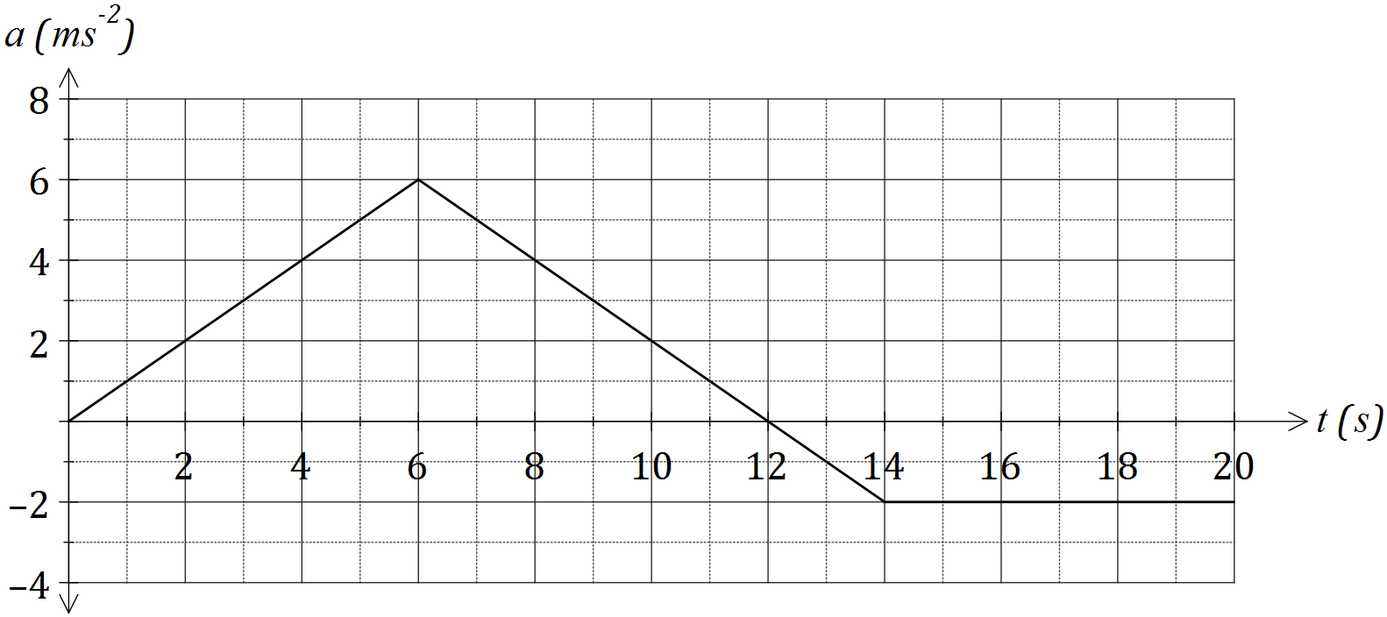

(a) Determine the velocity of the object when

(i) $t=6$. (1 mark)

|  |
| --- |
| **Solution** |
| $$v=\frac{1}{2}×6×6=18 \text{m/s}$$ |
| **Specific behaviours** |
| ✓ calculates area |

(ii) $t=20$. (2 marks)

|  |
| --- |
| **Solution** |
| $$v\left(20\right)=18+18-2-12=36-14=22 \text{m/s}$$ |
| **Specific behaviours** |
| ✓ calculates area above axes  ✓ calculates area below axes and subtracts from area above |

(b) At what time is the velocity of the body a maximum, and what is the maximum velocity?

(2 marks)

|  |
| --- |
| **Solution** |
| When $t=12$ seconds, $v_{MAX}=36$ m/s |
| **Specific behaviours** |
| ✓ identifies time  ✓ states maximum velocity |

(c) Determine the distance of the particle from the origin after $3$ seconds. (3 marks)

|  |
| --- |
| **Solution** |
| $$a=t⇒v=\frac{t^{2}}{2}⇒x=\frac{t^{3}}{6}$$ $$x\left(3\right)=\frac{27}{6}=4.5 \text{m}$$ |
| **Specific behaviours** |
| ✓ expresses $a$ in terms of  ✓ integrates twice to obtain displacement  ✓ uses $t=3$ to calculate displacement |

Additional working space

Question number: _________

Additional working space

Question number: _________

© 2016 WA Exam Papers. All Saints' College has a non-exclusive licence to copy and communicate this paper for non-commercial, educational use within the school. No other copying, communication or use is permitted without the express written permission of WA Exam Papers.